Radio signals
# Source: Chatgpt (GPT-5-Mini) at [1/23/2026]
Radio signals are a type of electromagnetic wave used to carry information wirelessly through the air. They are used in radio, TV, Wi-Fi, mobile phones, Bluetooth, GPS, and many other technologies.

🔊 What Are Radio Signals?
# Source: Chatgpt (GPT-5-Mini) at [1/23/2026]
- Radio signals are invisible energy waves that travel through space at the speed of light.
- They are part of the electromagnetic spectrum, with frequencies lower than visible light.

⚙️ Key Characteristics of Radio Signals:
# Source: Chatgpt (GPT-5-Mini) at [1/23/2026]
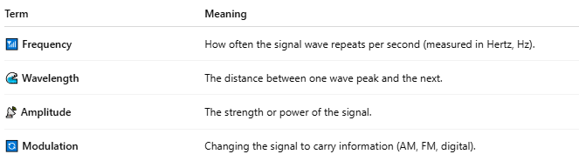

Term | Meaning
📶 Frequency | How often the signal wave repeats per second (measured in Hertz, Hz).
🌊 Wavelength | The distance between one wave peak and the next.
📡 Amplitude | The strength or power of the signal.
🔄 Modulation | Changing the signal to carry information (AM, FM, digital).

📡 How Radio Signals Work:
# Source: Chatgpt (GPT-5-Mini) at [1/23/2026]
- Transmitter creates and modulates the signal with information (sound, data, etc.).
- Antenna sends the signal through the air as electromagnetic waves.
- Receiver (radio, phone, router, etc.) captures the signal and decodes the information.

🧩 Where Radio Signals Are Used:
# Source: Chatgpt (GPT-5-Mini) at [1/23/2026]
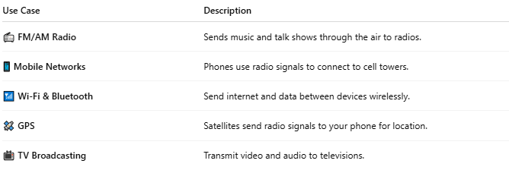

Use Case | Description
📻 FM/AM Radio | Sends music and talk shows through the air to radios.
📱 Mobile Networks | Phones use radio signals to connect to cell towers.
📶 Wi-Fi & Bluetooth | Send internet and data between devices wirelessly.
🛰️ GPS | Satellites send radio signals to your phone for location.
📺 TV Broadcasting | Transmit video and audio to televisions.

📖 Summary:
# Source: Chatgpt (GPT-5-Mini) at [1/23/2026]
A radio signal is an electromagnetic wave used to transmit data wirelessly over distances — from music on the radio to internet on your phone. It’s a core part of how modern communication and wireless technology works.

